ABU SALEH MD NOMAN

amdnoman

Minority Report (2002)

Sci-Fi movies and HCI

The prototypes or mockups of future technologies found in this movie are as follows (the names are hypothetical based on their functionality):

**Hand gesture gloves**:

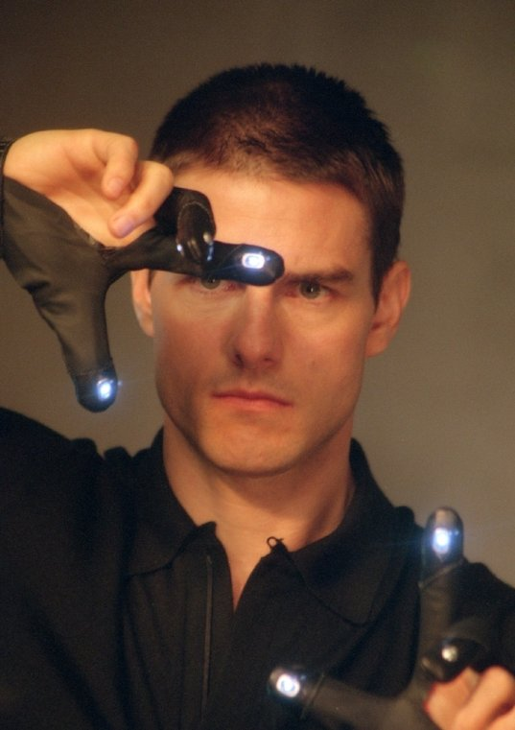

These specially designed gloves were used by the actor Tom Cruise to navigate through the screens. It enabled him to zoom in, zoom out, drag and drop, remove pictures from display etc. These device is gesture controlled and illuminated by a LED.

**Projector of 3D image**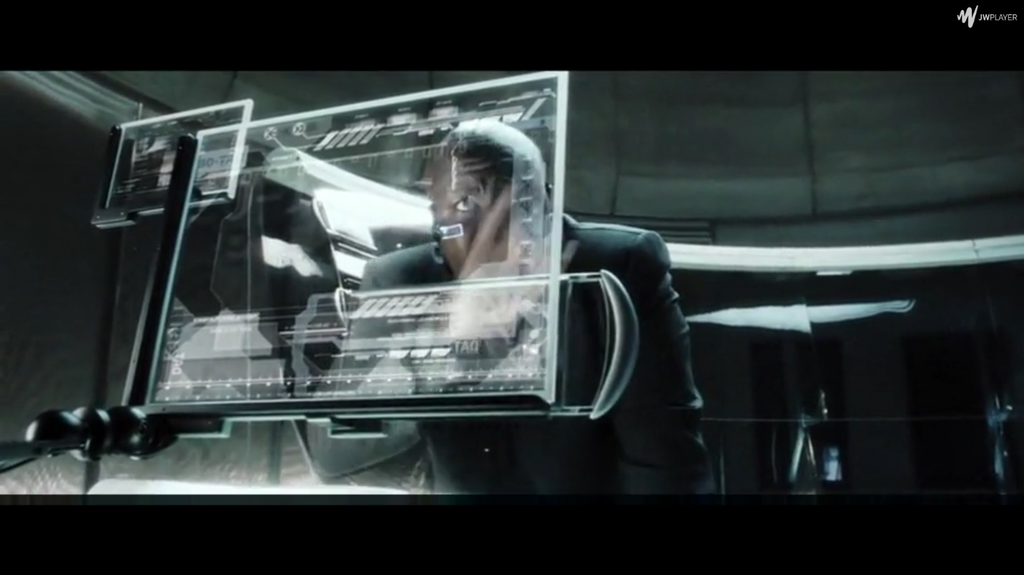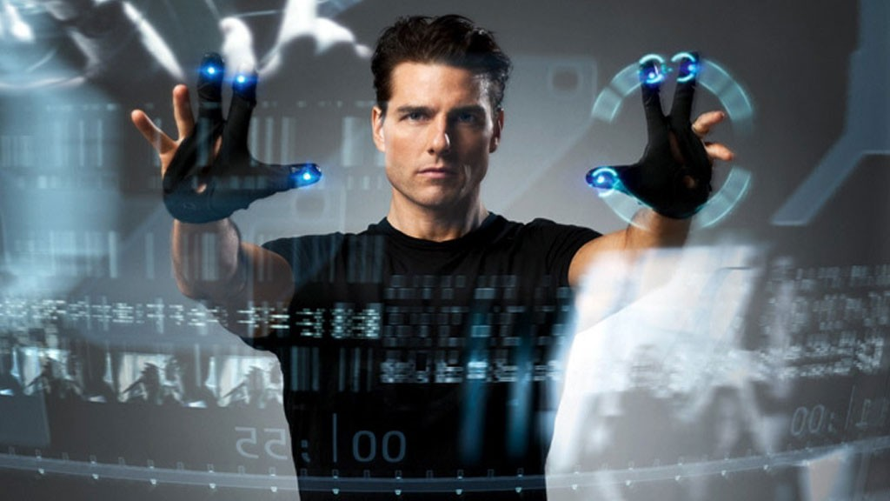

As depicted in the picture, 3D images can projected into a transparent display and can be maneuvered using the gloves. This technology uses advanced image processing and pattern recognition techniques. This is unlike the touch screen that we use today but indeed is handful as gesture enable displays ca further alleviate the need to directly interact with computers.

**Virtual Reality**

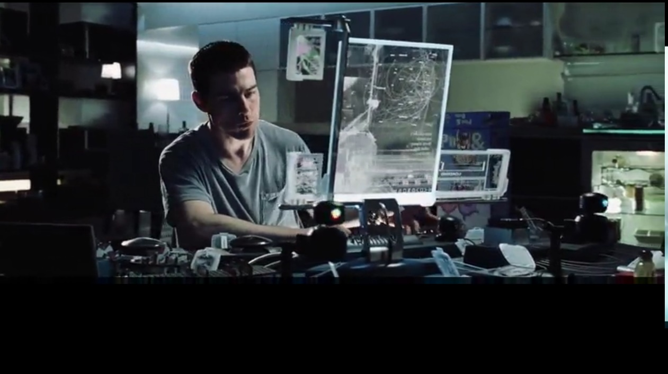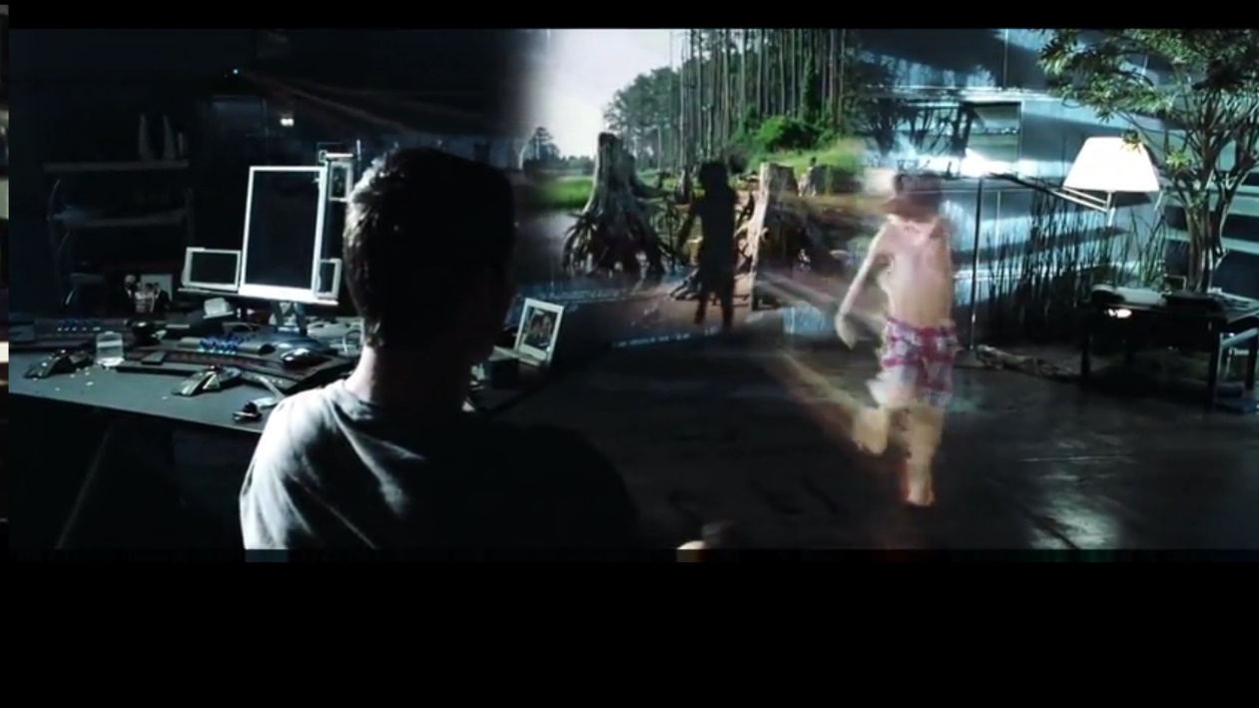

Virtual reality refers to the technology that enables users to physically sense, feel and touch an imaginary world. In the movie, Tom Cruise, with the help of transparent display, projector and special kind of ‘prevision disc player’, can relive the reminiscences of his lost son and separated wife.

**Future Vehicles**

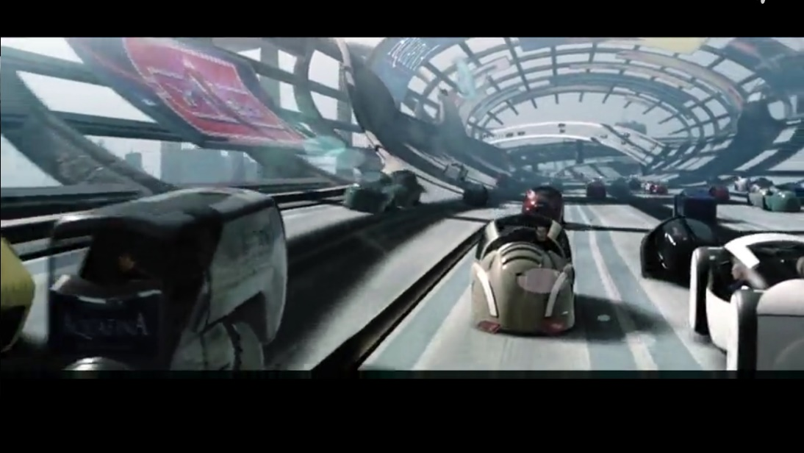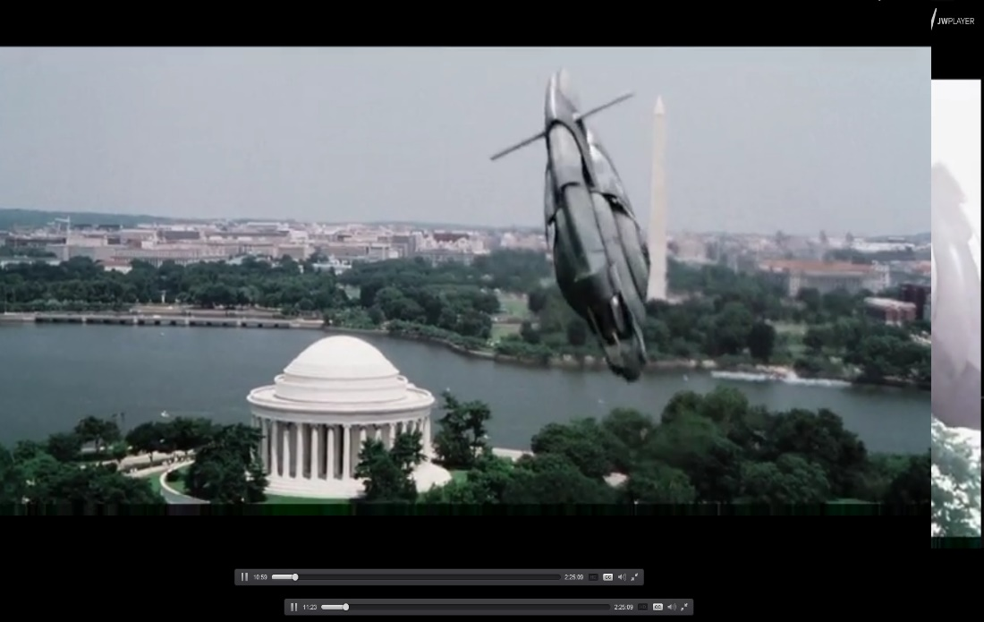

In the movie the director envisioned on special kind of car which is depicted above. These cars are specially designed so that they can move in horizontal and vertical roads and can slide through. The flying machine in the following image is shown as a special fast transportation for the cops.

**Iris scan**

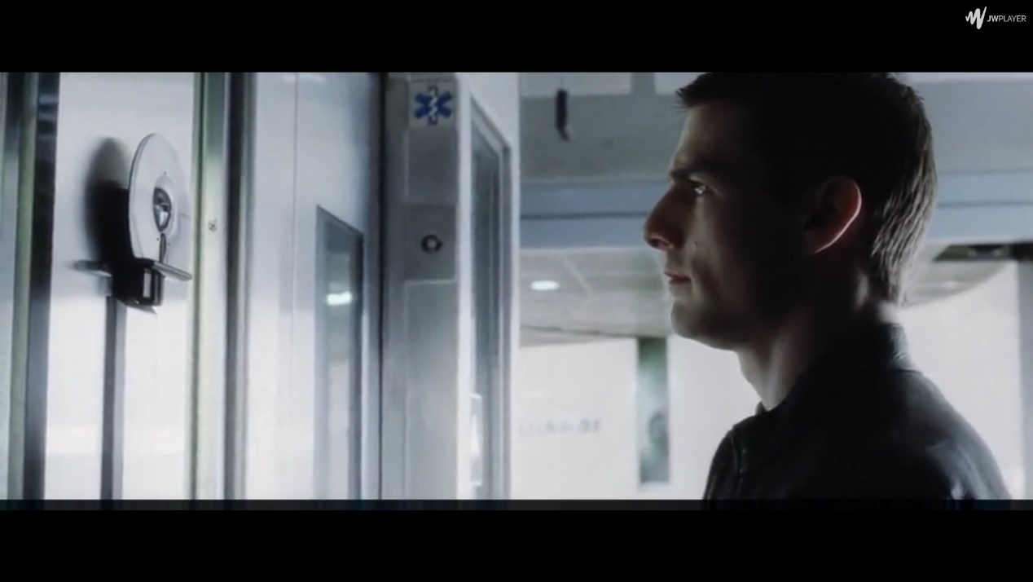

This is another example of innovative thinking of the director. This film introduces the idea of iris scanner which can uniquely identify each individual by scanning their iris of the eye. This in fact has become a reality nowadays.

**Flying Cops**:



As shown in the picture, the movie makes us believe that in future cops can fly wearing a special purpose jacket which enables them to reach the suspect quickly.

**Personalized digital ads**

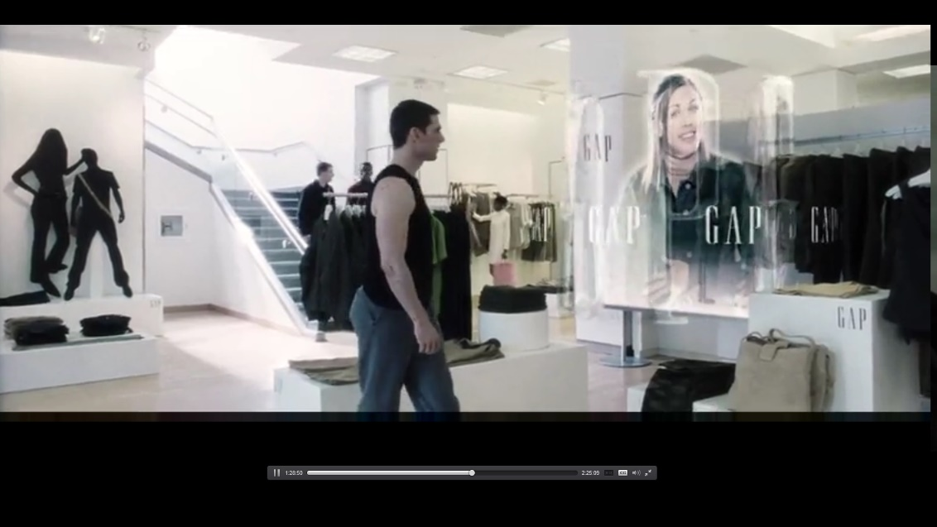

Personalized digital ads are shown for each customer whenever the returning customers visit the store. In the image we can see the director envisioned one such customer care specialist of GAP. It welcomes Tom Cruise, asks for any help and reminds him of his previous visit to the store.

In fine, it can be said that the movie inspires HCI and UX designers to create new prototype for future development. This movie was released in 2002. Afterwards, few of these technologies are coming to reality and some are in development phase. This clearly, Sci-Fi movies can offer great help in terms of designing new technology, stem new ideas and better Human-Technology Interaction design.